**Spring 2024: CS5720 Neural Networks & Deep Learning - ICP-2**

**Eekshitha Gujjala (700741491)**

GitHub Link: <https://github.com/Eekshi2001/neuralnetworksanddeeplearning>

ICP2 Video Link: <https://drive.google.com/file/d/1VrsJHAoEPETykQ_m4ehIBT1k6ommDyc5/view?usp=share_link>

1. Write a program that takes two strings from the user: first_name, last_name. Pass these variables to fullname function that should return the (full name).

Forexample:  
 First_name = “your first name”, last_name = “your last name”

Full_name = “your full name”

Writefunctionnamed“string_alternative”thatreturnseveryothercharinthefull_namestring. Str = “**G**o**o**d e**v**e**n**i**n**g”  
Output: Go vnn

**Note: You need to create a function named “string_alternative” for this program and call it from main function.**

**Solution:**

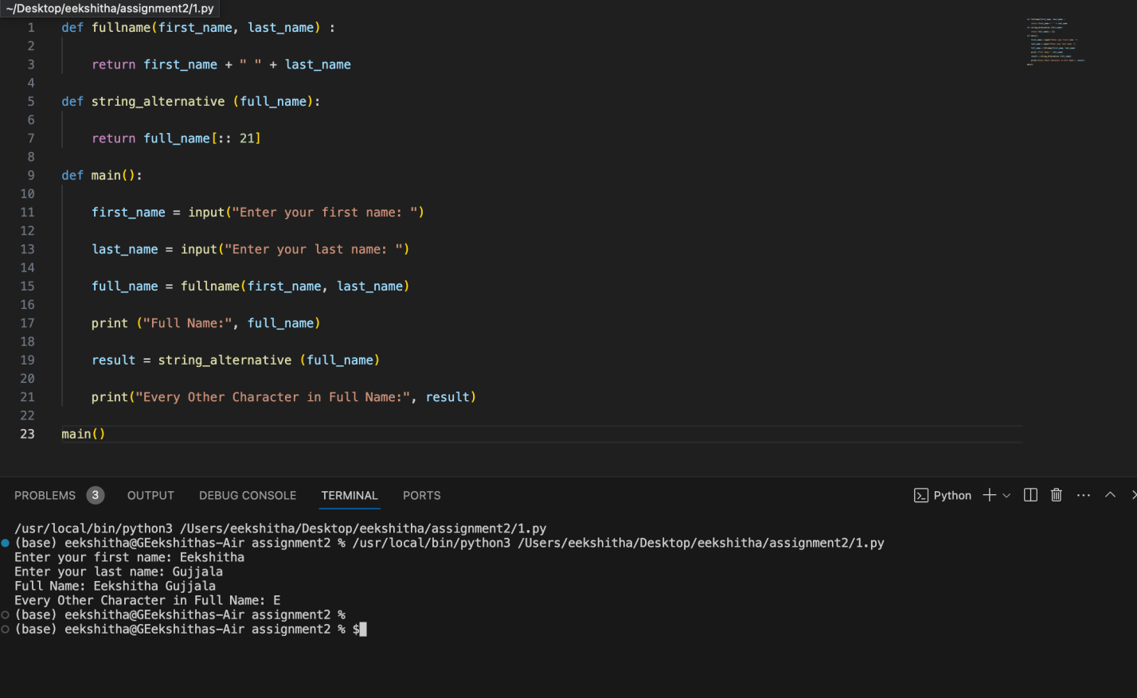

2.Write a python program to find the wordcount in a file (input.txt) for each line and then print the output. o Finallystoretheoutputin**output.txt**file.

solution:

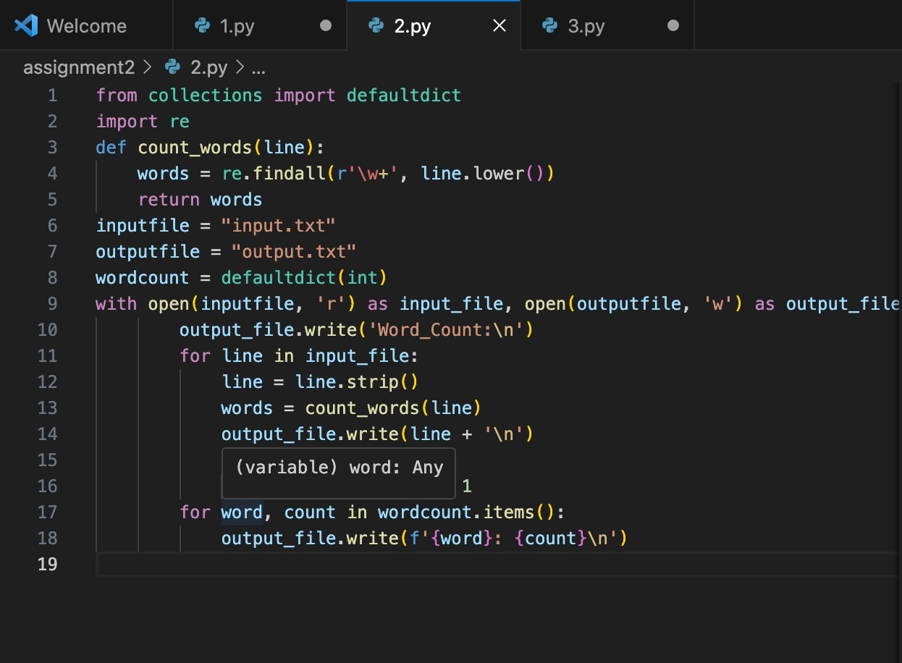

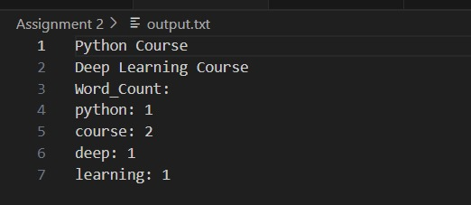

3. Write a program, which reads heights (inches.) of customers into a list and convert these heights to centimeters in a separate list using:  
1) Nested Interactive loop.  
2) List comprehensions

**Solution:**

